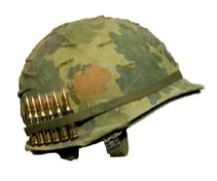**THE IMMUNE SYSTEM |** The body’s line of defence **PEARSON 9** page 261 – 262

The immune system: **The system that fights off infection.**

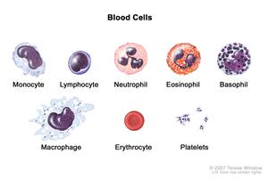**FIRST LINE** - **Barriers**

|  |  |
| --- | --- |
| 1 **Skin** | Protects the **internal organs** from harmful chemicals in the environment & sunlight. |
| 2 **Fluids** | **• Tears** – contain **mild antiseptic properties** to wash away dust & harmful substances from  openings.  **• Mucus** – traps dust & unwanted particles & it is removed from the body by coughing or sneezing.  **• Saliva** – contain **mild antiseptic properties** to wash away dust & harmful substances from  openings. |
| 3 **Hair** | Traps & filters air |
| 4 **Acid** | Kills pathogens in the stomach. |
| 5 **Purging processes** | **• Vomiting** – a quick way of getting rid of pathogens **in** the stomach.  **• Diarrhoea** – a quick way of getting rid of pathogens that are present **after** the stomach. |

**SECOND LINE** - **Fighters**

**White blood cells - neutrophils**

**Starts** when: a pathogen enters the body tissues.

**Inflammation**: A response of the body to infection; when the affected area becomes red, hot and swollen.

**Damaged cells** release: a chemical that causes an increased amount of blood to flow to the infected area.

**Neutrophils**: consume pathogens. Dead neutrophils form the yellow pus around wounds.



**THIRD LINE** - **Fighters & note-takers**

**White blood cells – lymphocytes & macrophages**

The **lymphatic** system: A series of vessels and capillaries that carry fluid from around your cells back to the heart.

**Macrophages:** consume and destroy pathogens. **Lymphocytes:** makes a chemical called an antibody.

Function: Antibodies cause pathogens to clump together, making it easier for macrophages to destroy them.

Reason for **swollen lymph nodes**: They contain a large number of lymphocytes & macrophages killing pathogens.

**Spleen**: It removes pathogens & foreign proteins from the lymph fluid.

Reason for a **rise in temperature**: To disrupt pathogens from functioning effectively, making it easier to destroy.

**Immunity**

• The first time lymphocytes meet a pathogen, they make antibodies which work on the pathogen.

• The next time the pathogen appears, lymphocytes can quickly make antibodies before it can make you unwell.